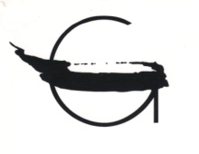
14th GIELNIAK GRAPHIC ARTS COMPETITION 2017-2018

SUBMISSION FORM

Surname:

First name:

Address:

Phone/Fax numer:

E-mail address:

Date and Place of Birth:

Nationality:

Artistic Education:

Major Exhibitions:

Submitted Works:
 | Title | Technique | Paper size (height x width) | Print size (height x width) | Date of Creation
1 |  |  | cm | cm
2 |  |  | cm | cm

I hereby declare that I have become acquainted with the Rules of the Competition, I accept their content and I commit myself to respect their regulations.

Date: .......................... Signature: .......................

